Assignment No 1
GHAZI UNIERSITY D.G KHAN
Subject:
“ Programming Fundamentals lab 2”
Submitted By:
Name: “ Sadia Shamroze”
Class: “ BS Computer Science ”
Section : “ C ”
Submitted To:
“ Prof. Asad Majeed “

Lab Task 1
Run these programs and observe their outputs.
(1)
Handwritten Code
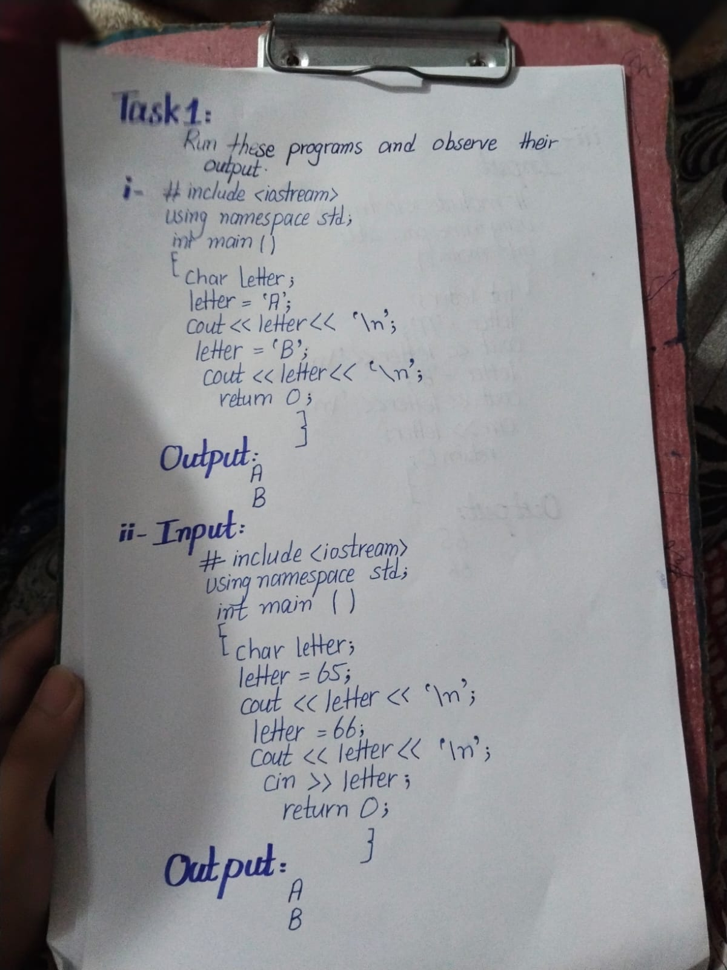
Code written on phone/desktop
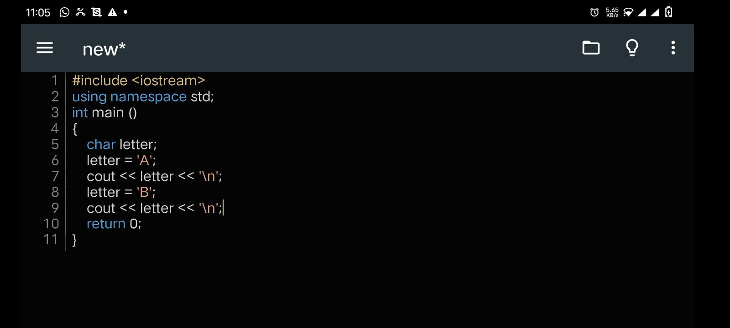

Code Output
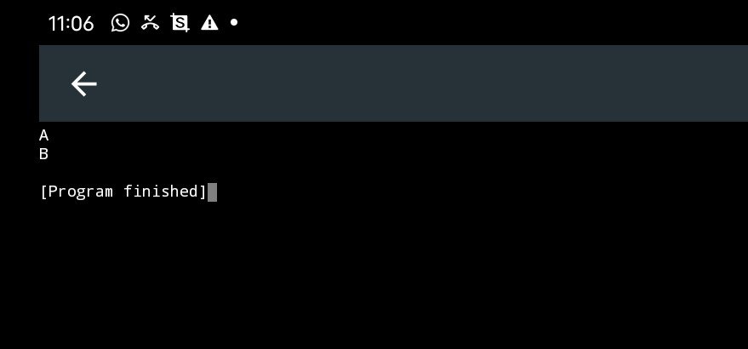

(2)
Handwritten Code

Code written on phone/desktop
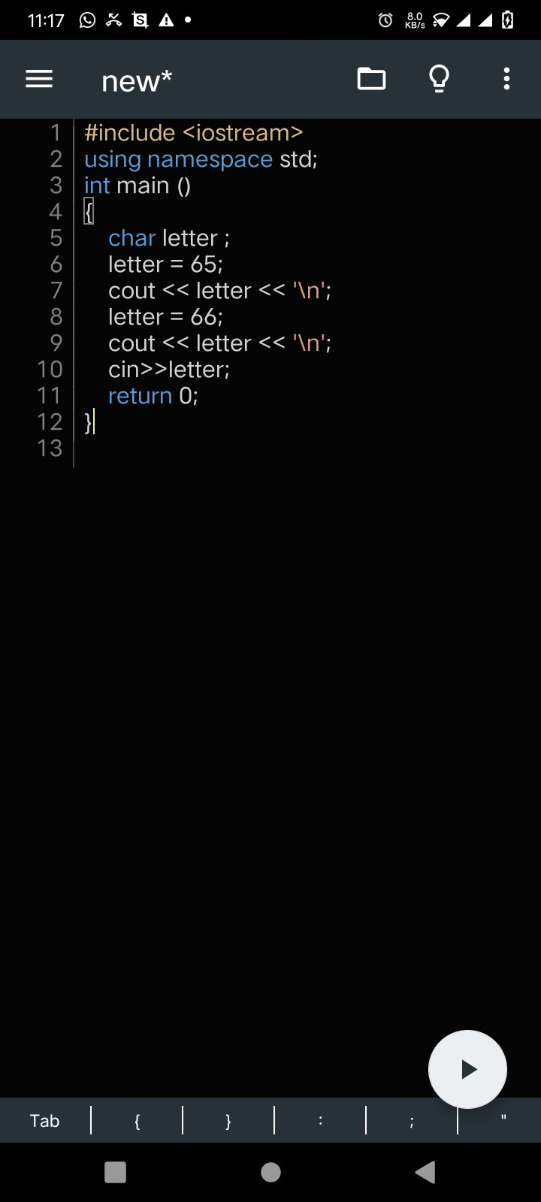
Code output
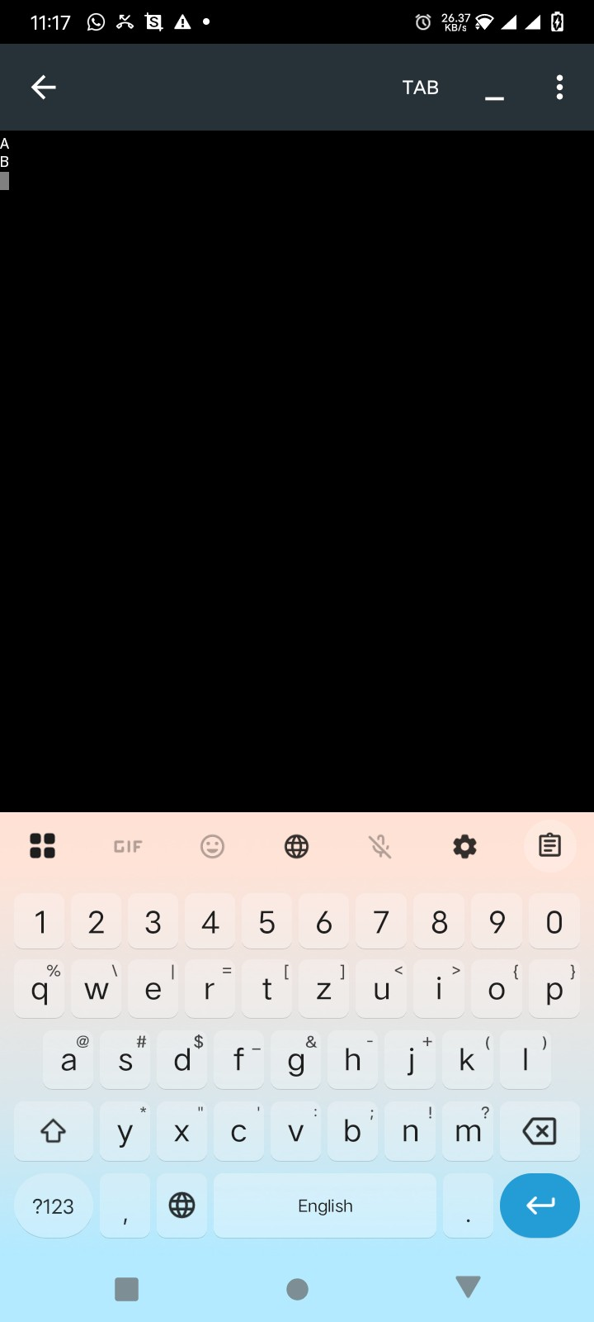
(3)
Handwritten Task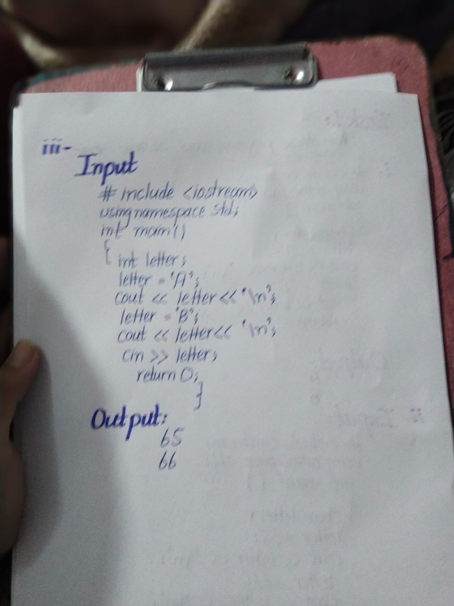Code Written on phone/desktop
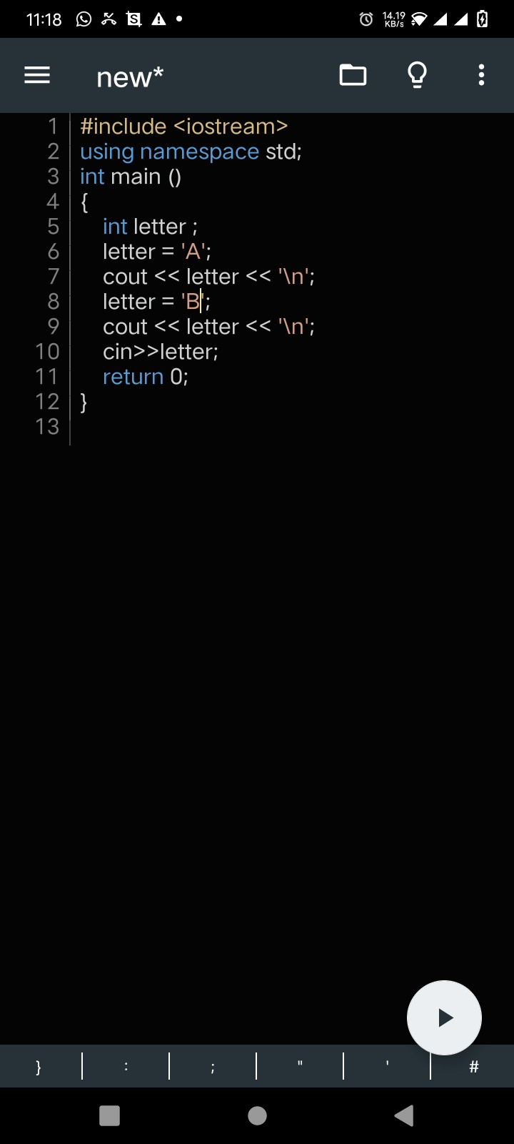
Code Output
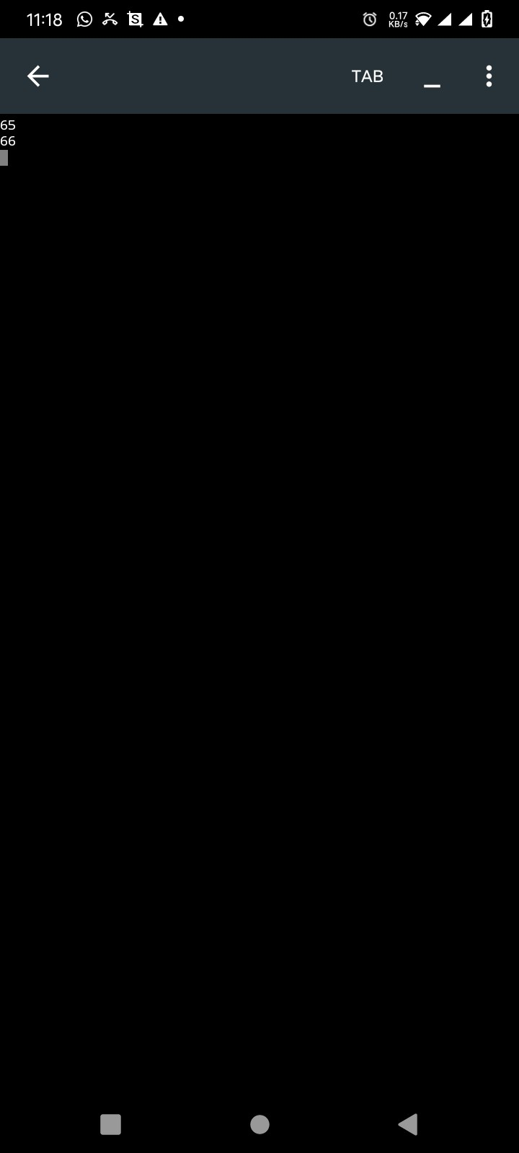

Lab Task 2:
Take two integers as the input from the user apply athematic operations on them (+,-,*,/) as print them on the screen.
Handwritten Code:
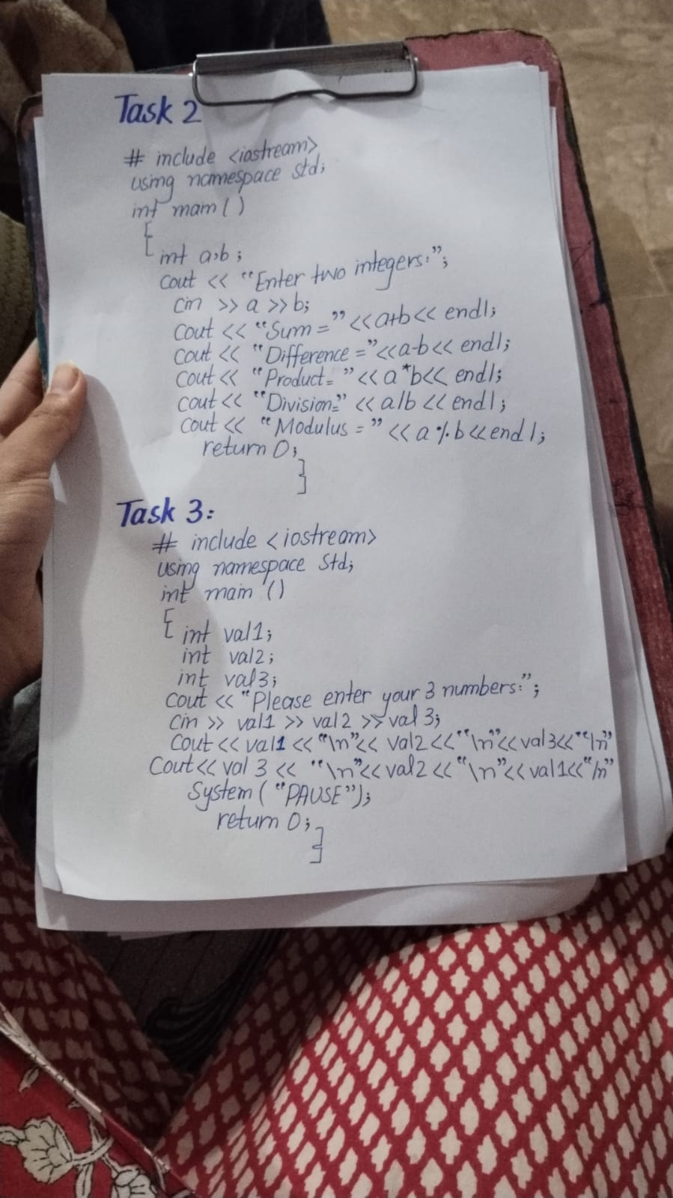
Code Written on phone/desktop screen
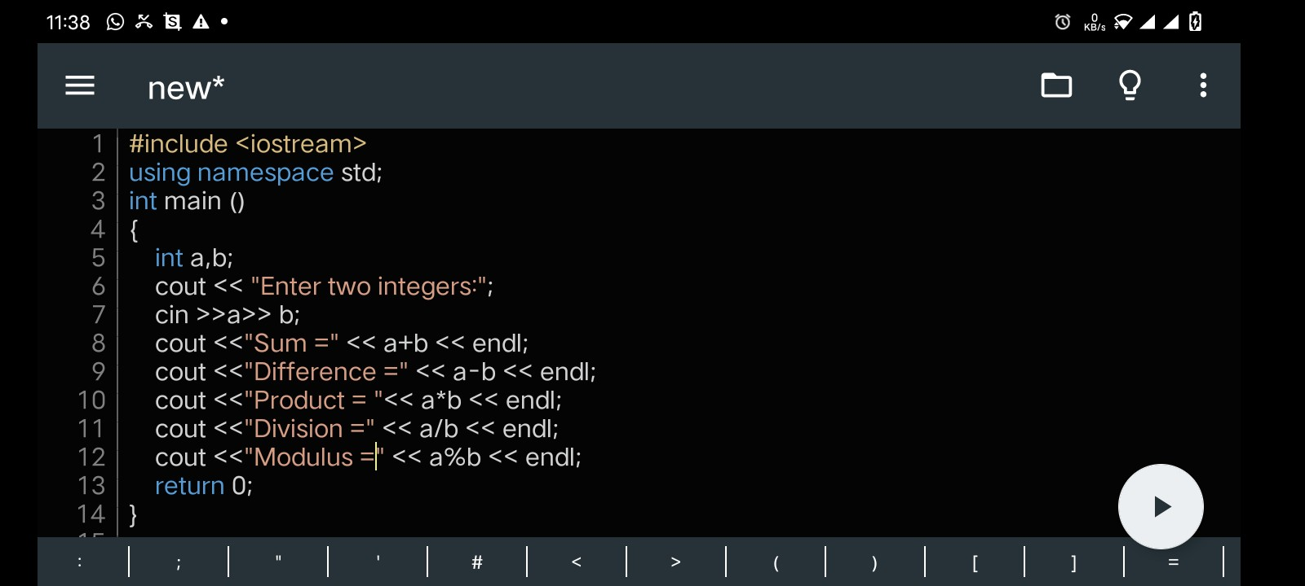
Code Output
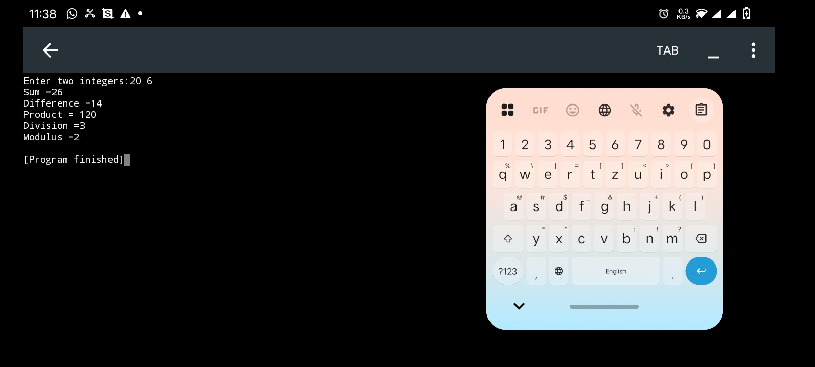

Lab Task 3:
Handwritten Task:

Task written on the desktop/phone:

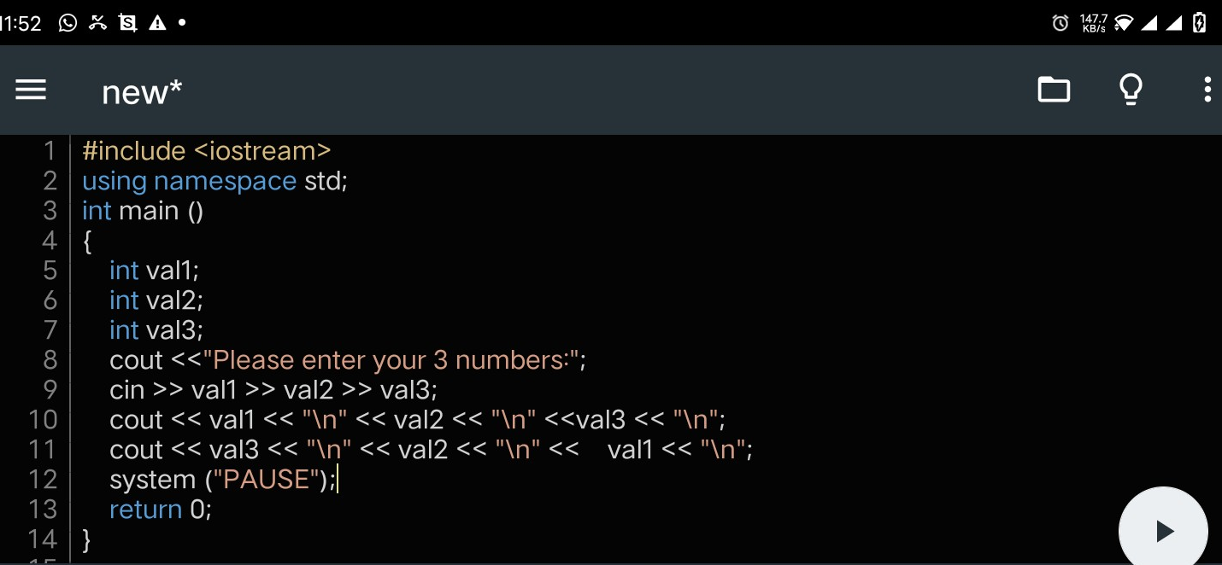
Code Output:
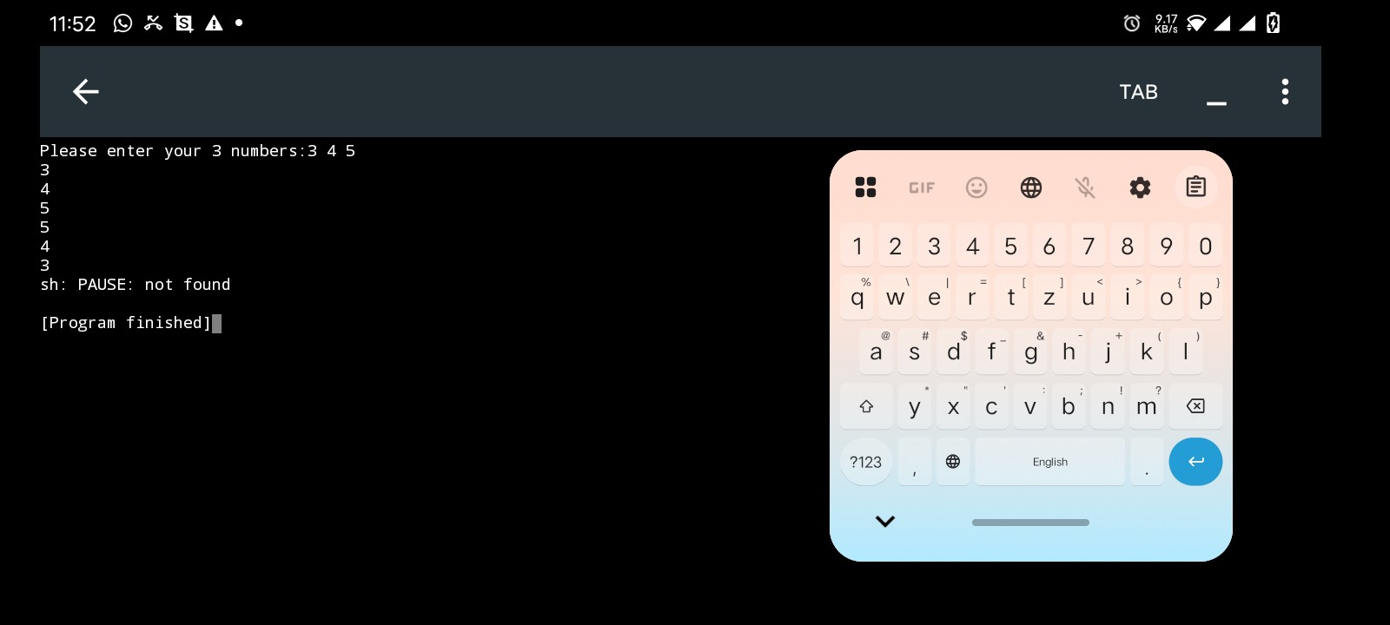

Lab Task 4
Handwritten Code
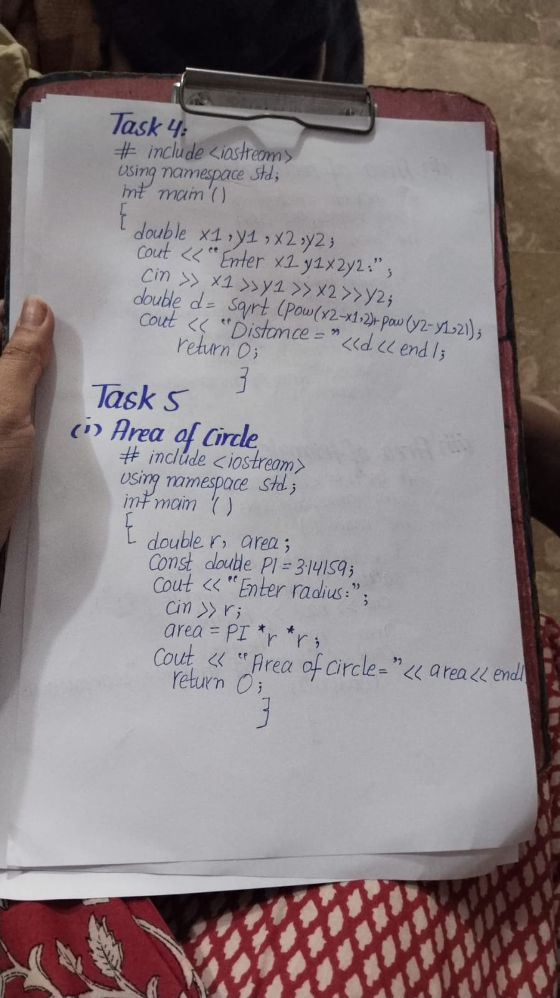

Code written on desktop/phone

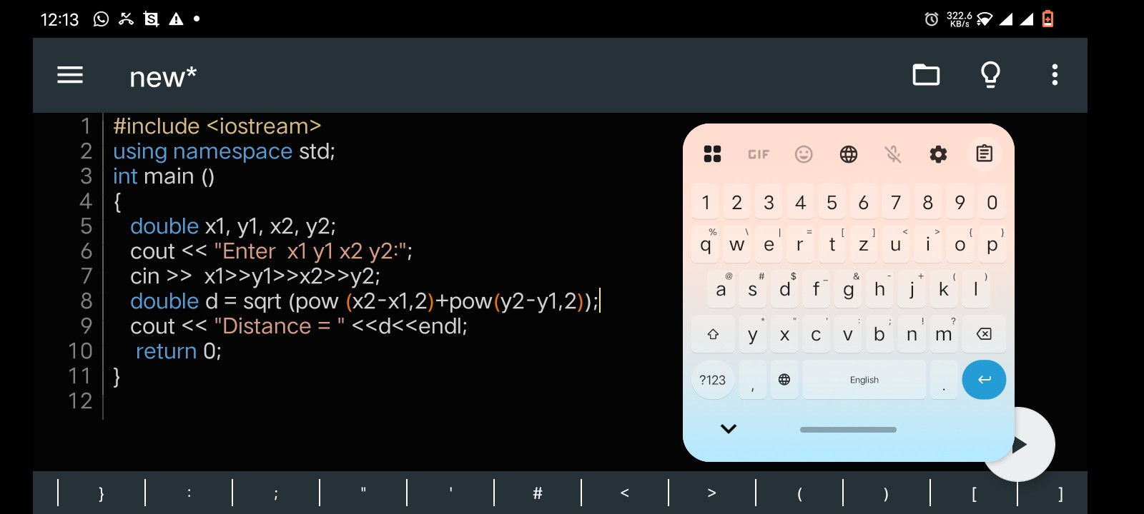
Code Output

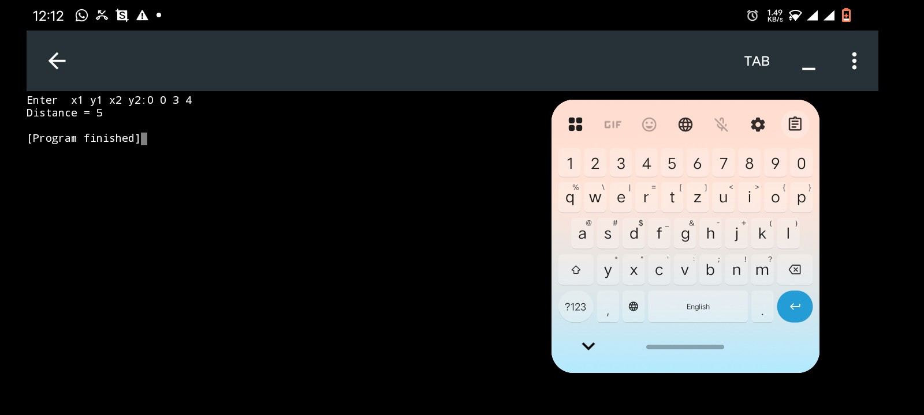
Lab Task 5
(1)
Area of a circle
Handwritten Code
Code Written on desktop/phone
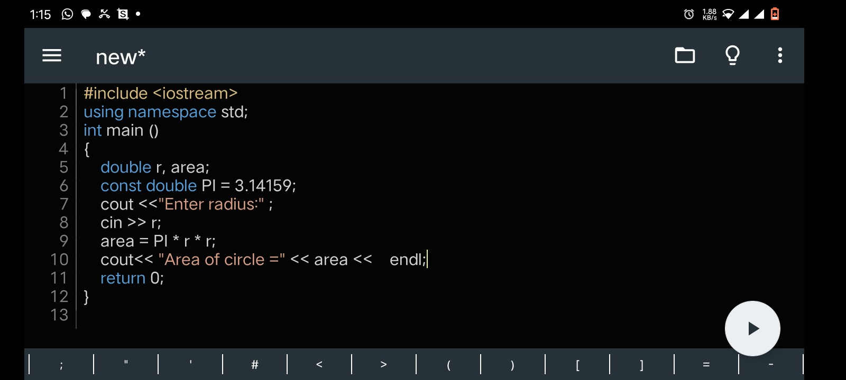
Code Output
(2)
Area of Rectangle
Handwritten Code
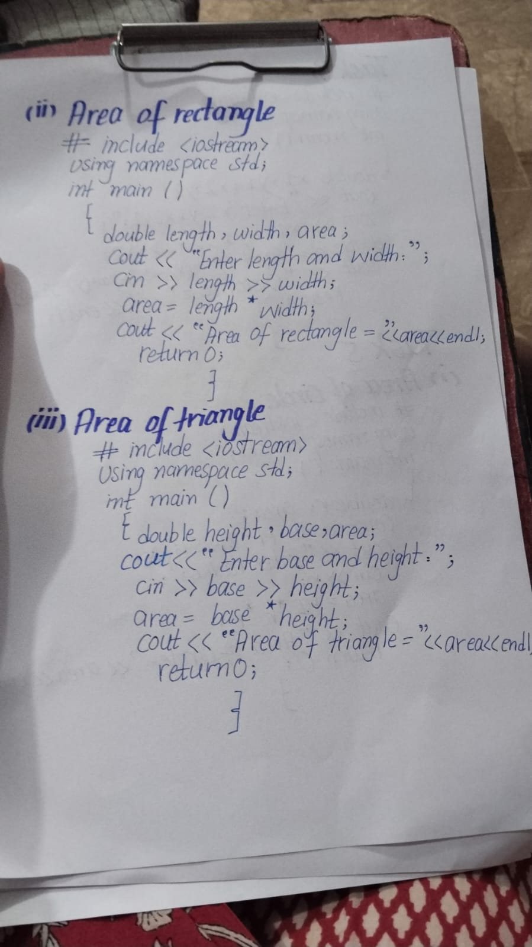
Code Written on desktop/phone
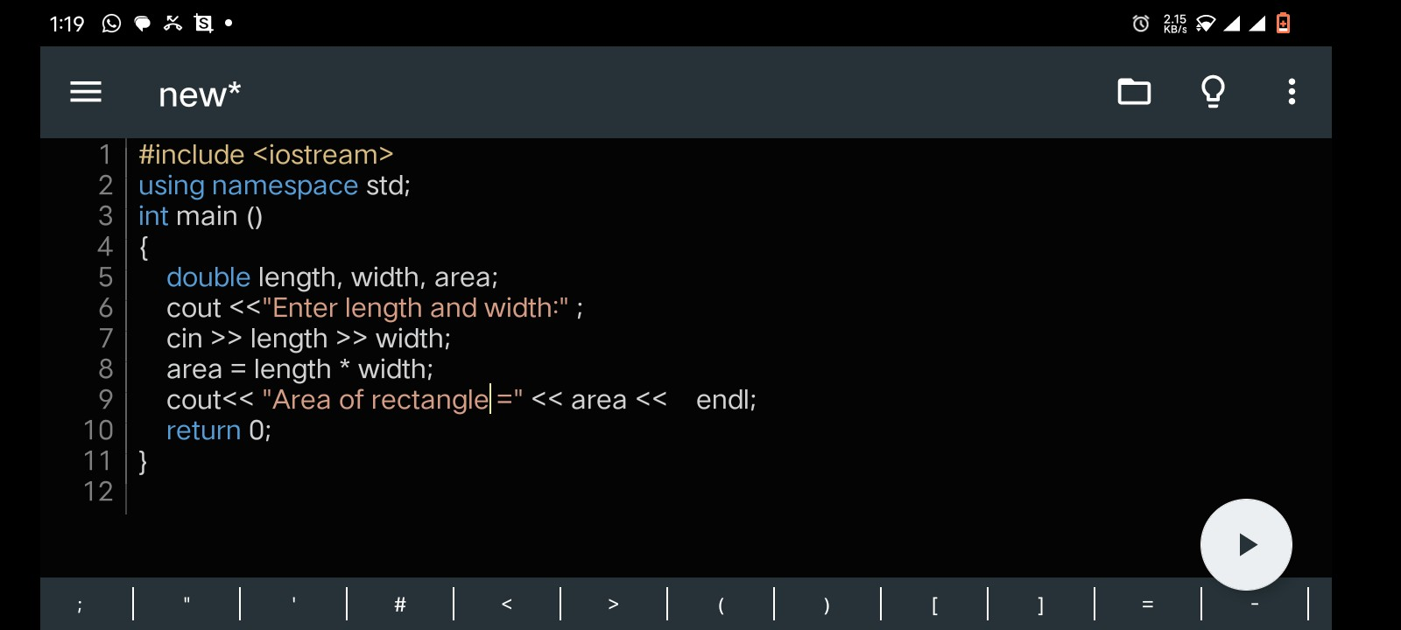
Code Output

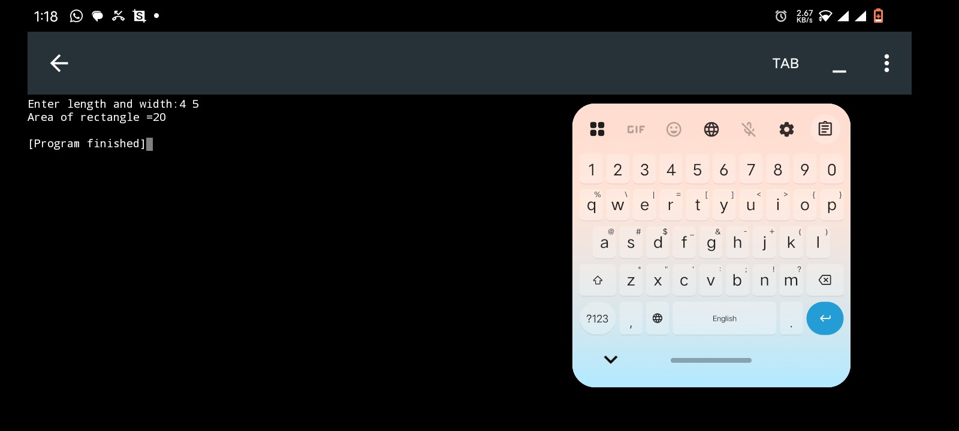
(3)
Area of Triangle
Handwritten Code
Code Written on desktop/phone
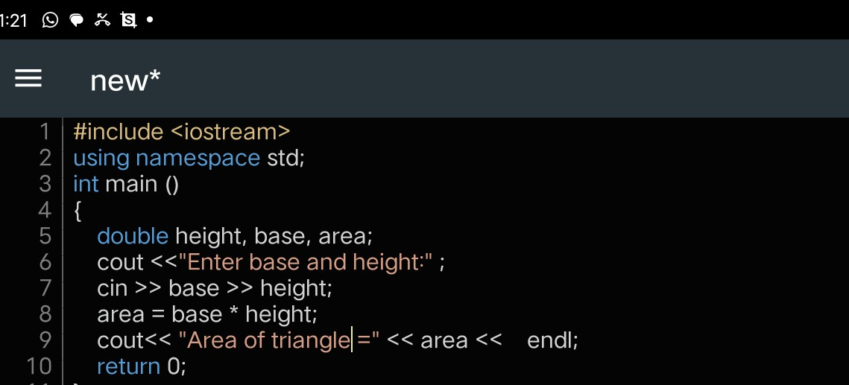
Code Output
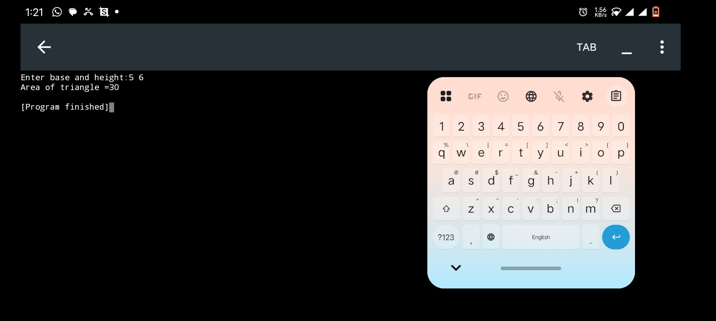

Lab Task 6
Handwritten Code
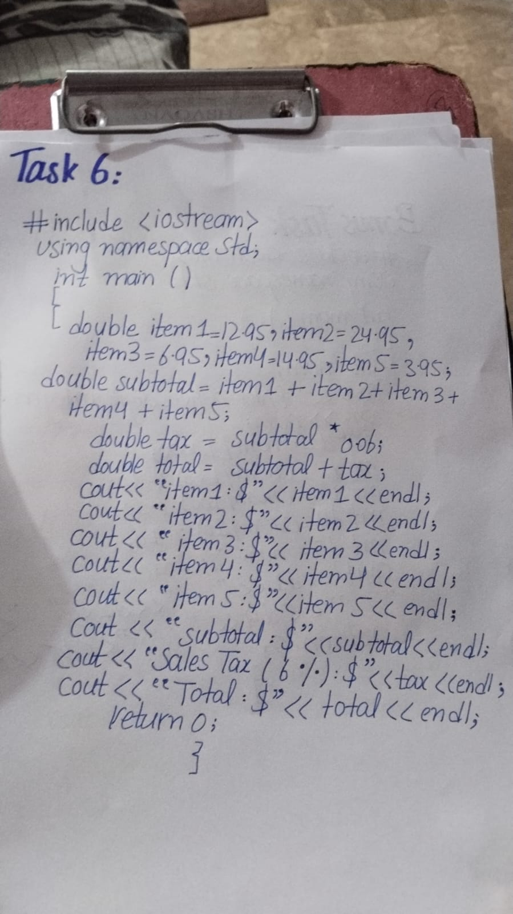

Code Written on desktop/phone
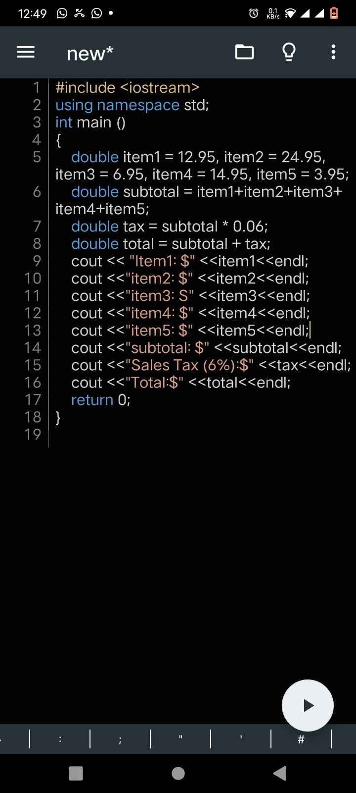
Code Output
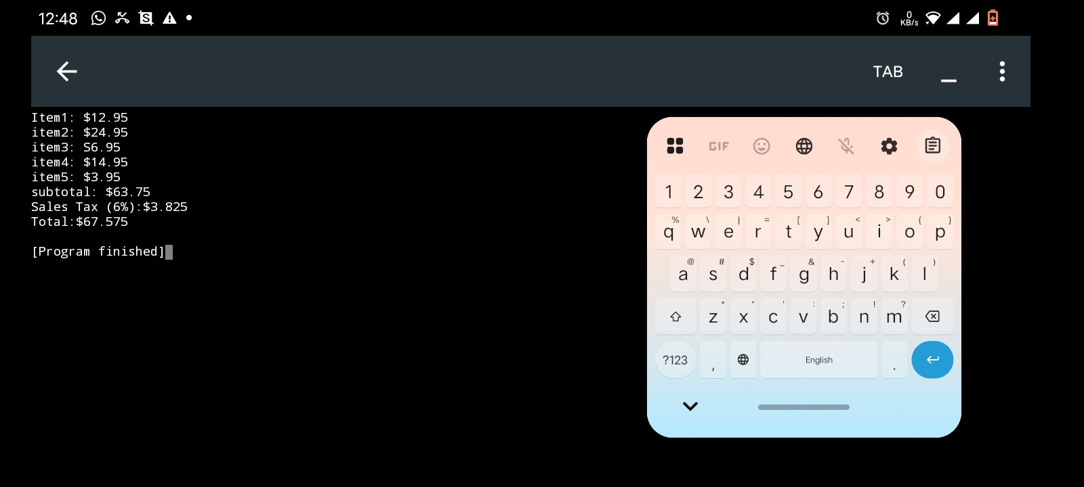

Bonus Task
Handwritten Task
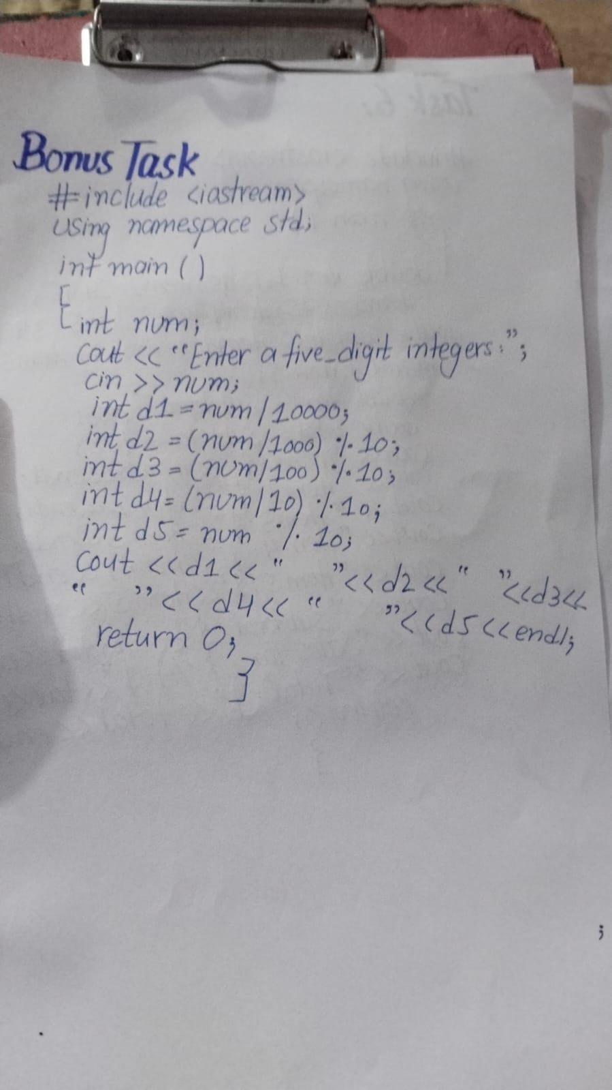
Code Written on desktop/phone
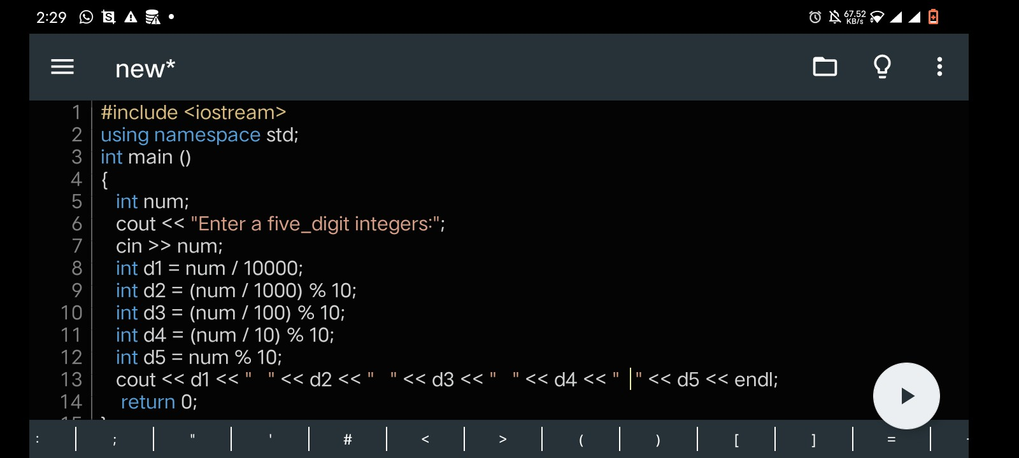

Code Output
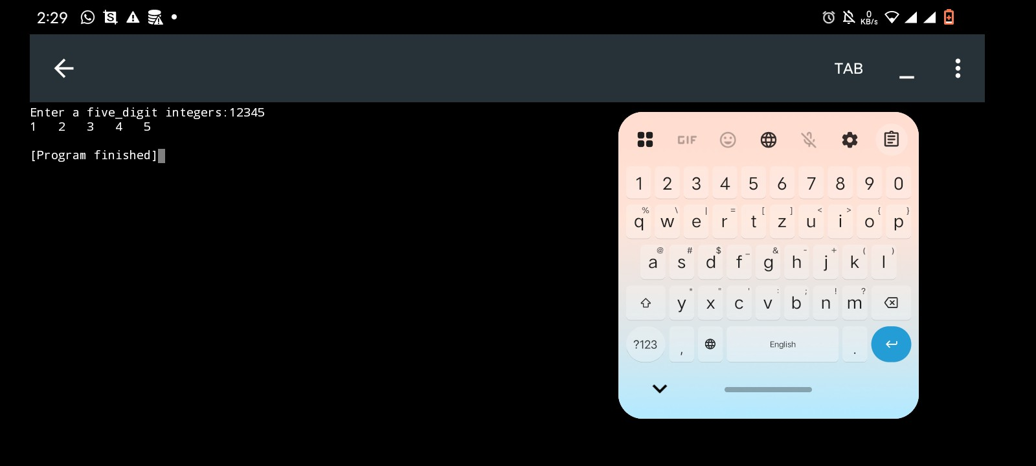

Home Task 1
Handwritten Code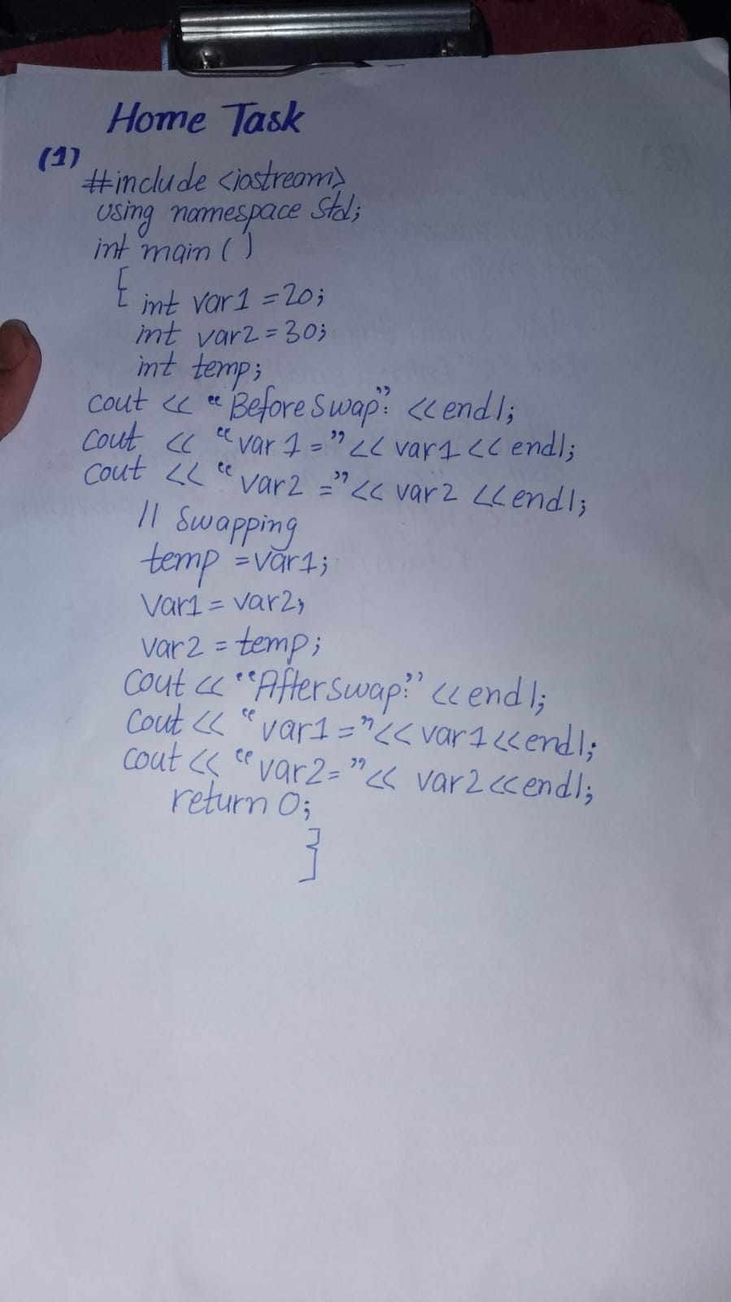
Code Written on desktop/phone
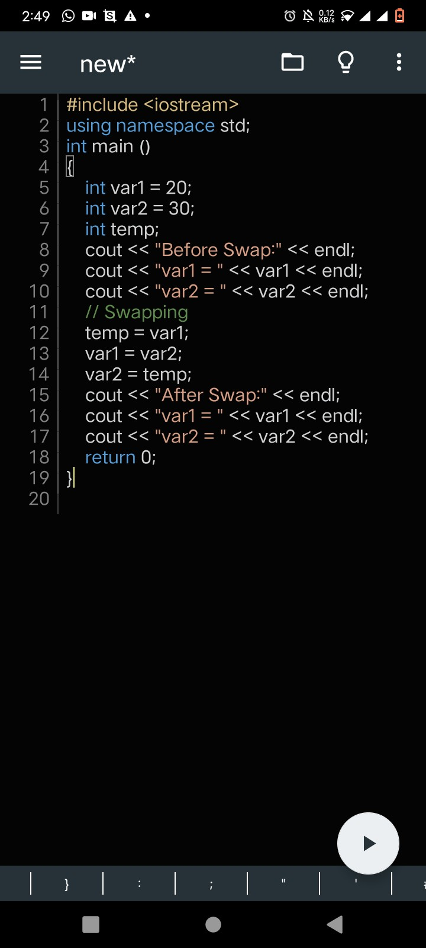
Code Output
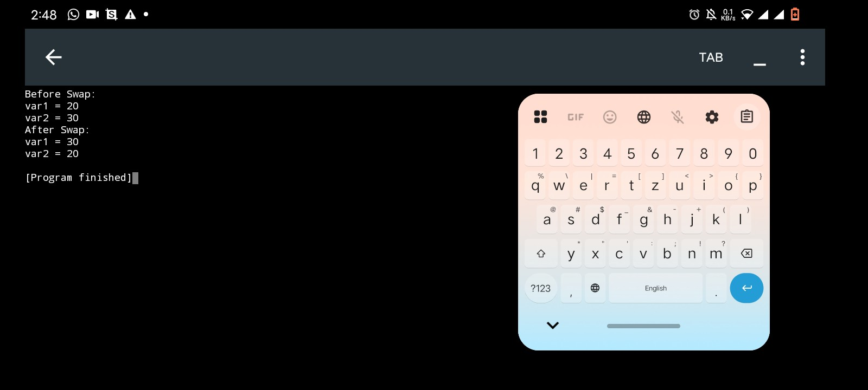

Home Task 2
Handwritten Code
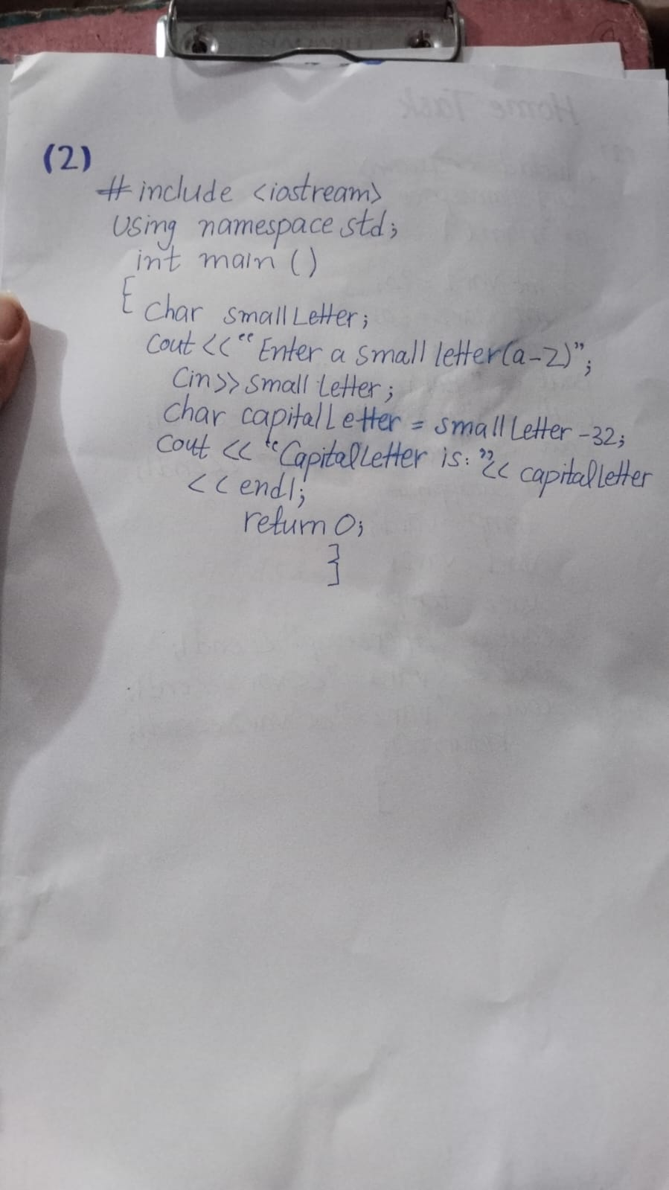
Code Written on desktop/phone
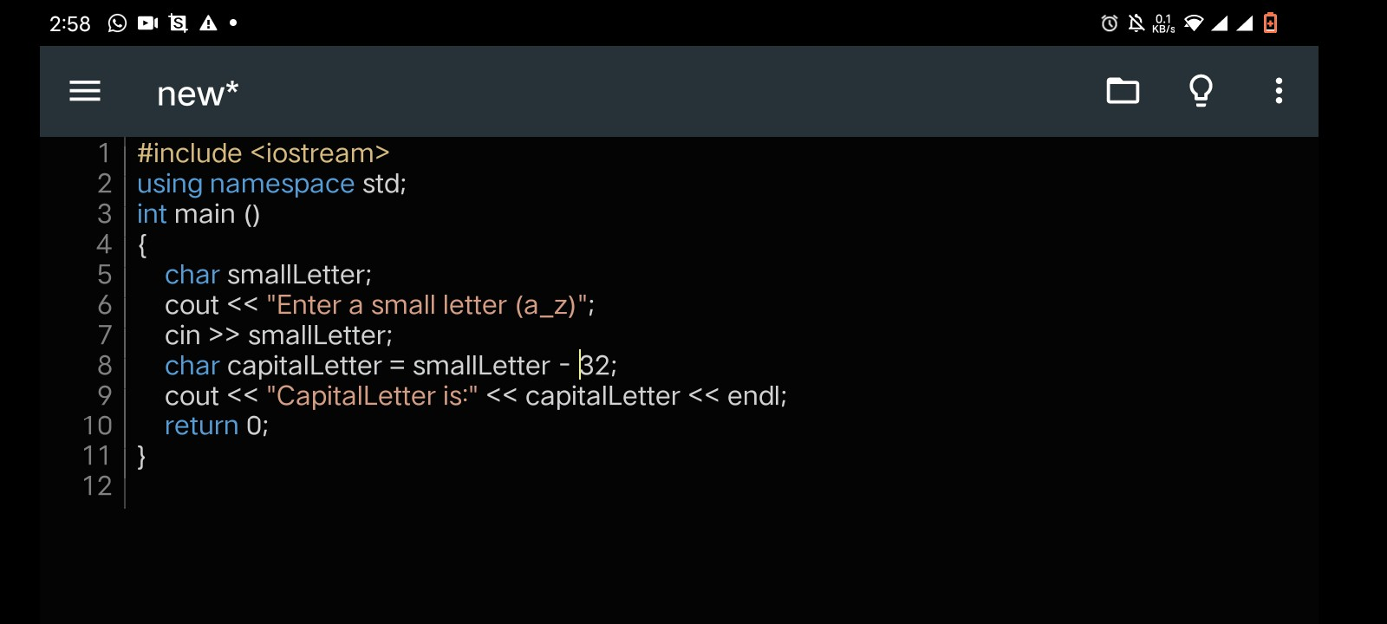
Code Output
